Neural Network

Model Representation 1

Model Representation 2

Examples and Intuitions 1

repeats for OR function

Examples and Intuitions 2

XNOR logical operator:

Calculation

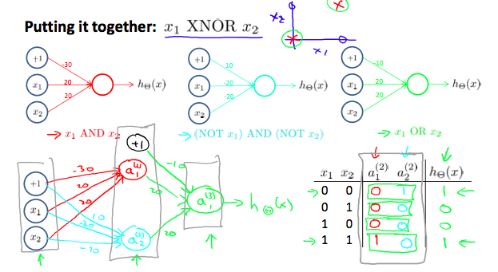

Multiclass Classification